**9701 Temp Sensor 1602 LCD**

This Arduino sketch reads the temperature from a 9701 temperature sensor and displays it, in degrees F, on a 1602 LCD display (16 x 2).

**The 9701 Temperature Sensor**

The 9701 is a small, very low-cost temperature sensor. The datasheet is generally written for the 9700/9700A/9701/9701A. The whole family of sensors are presumably similar enough they can share a single datasheet.

The 9701 is fed a VCC, 5V in the case of the Arduino, and a ground. It sends back to the Arduino’s analog input pin a voltage signal from which the temperature, in degrees Celsius, can be calculated.

**The 1602 16x2 LCD Display**

The display is a common display for Arduino users. The documentation that I copied for it calls it a Hitachi HD44780. I don’t understand how “1602” corresponds to “Hitachi HD44780,” but I’m sure there is a connection.

The LCD requires the use of a #include LiquidCrystal library in the sketch.

**The Circuit**

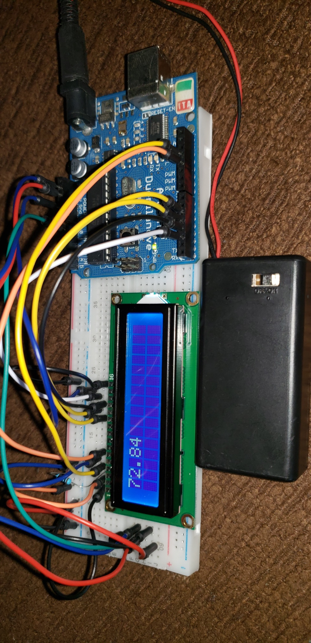

The 9701 is just left of the 16x2. It is hard to see in the picture. The 16x2 LCD is easy to see. The Arduino Deumilanova is to the right.

Connecting the LCD to the Arduino is shown below . . . kind of. I copied the image from the documentation that I received with my display when I received it. The Arduino is depicted as an ethernet shield! Well, the wiring is still depicted correctly, it’s just on the wrong circuit board. For example, the wiring on the digital side of the Arduino starts on the “third socket from the right,” which is digital 2.

